**SPOTIFY ADVANCE SQL ANALYSIS**

SELECT TOP (1000) [Artist]

,[Track]

,[Album]

,[Album_type]

,[Danceability]

,[Energy]

,[Loudness]

,[Speechiness]

,[Acousticness]

,[Instrumentalness]

,[Liveness]

,[Valence]

,[Tempo]

,[Duration_min]

,[Title]

,[Channel]

,[Views]

,[Likes]

,[Comments]

,[Licensed]

,[official_video]

,[Stream]

,[EnergyLiveness]

,[most_playedon]

FROM [Spotify_DB].[dbo].[Spotify_Dataset]

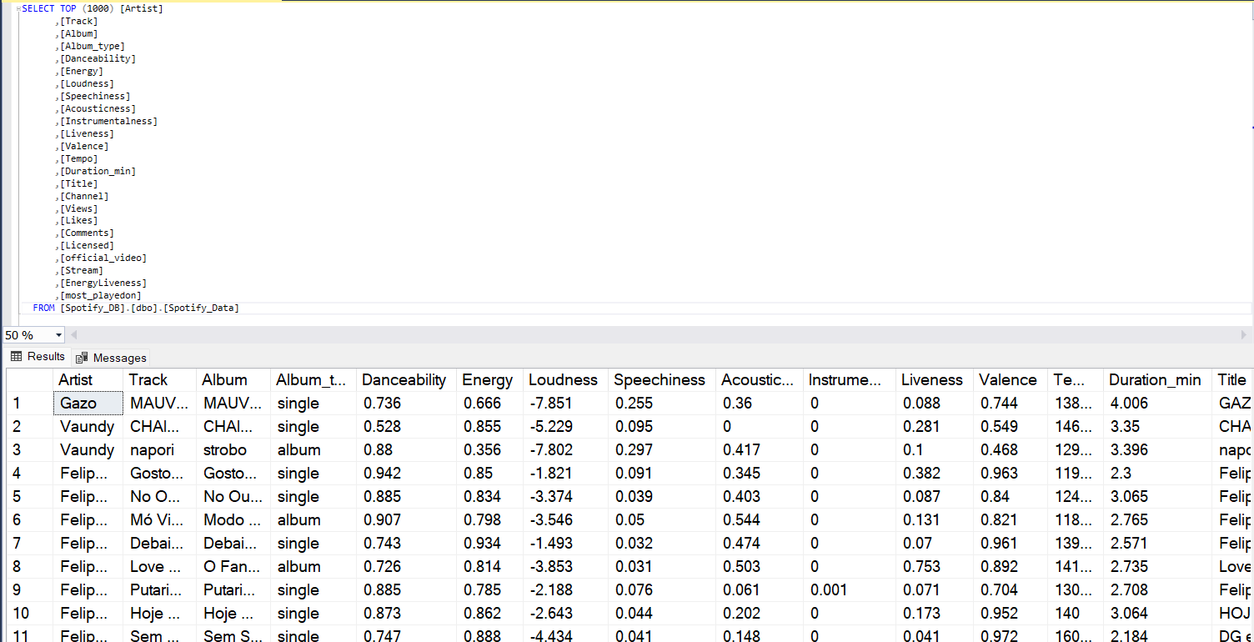

**EXPLORATORY DATA ANALYSIS**

How many records are there?

SELECT COUNT(*) Total_Records FROM Spotify_Data

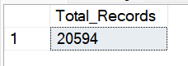

What is the Total Number of Unique Artist we have?

SELECT COUNT(DISTINCT Artist) Total_Numb_of_Artist FROM Spotify_Data

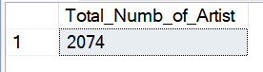

What is the Total Number of Albums?

SELECT COUNT(DISTINCT Album) Total_Numb_of_Album FROM Spotify_Data

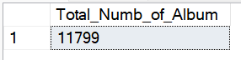

What are the Album type available?

SELECT DISTINCT Album_type FROM Spotify_Data

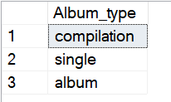

What is the Maximum and Minimum Duration of a Song?

SELECT

MAX(Duration_min) Max_Duration,

MIN(Duration_min) Min_Duration

From Spotify_Data



Some songs are having 0 duration that cannot be possible so we need to get rid of those errors

SELECT * FROM Spotify_Data

WHERE Duration_min = 0



So we will Delete these two records

DELETE FROM Spotify_Data

WHERE Duration_min = 0

SELECT * FROM Spotify_Data

WHERE Duration_min = 0



Now How many records are there?

SELECT COUNT(*) Total_Records FROM Spotify_Data



How many channel we have?

SELECT COUNT(DISTINCT Channel) Number_of_Channels FROM Spotify_Data



What are the Platform in which we segment most popular

SELECT DISTINCT most_playedon FROM Spotify_Data

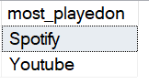

===================================================

**Data Analysis Basic level**

**==**=================================================

(Q1) Retrieve the names of all tracks that have more than 1 billion stream

SELECT Track, Stream FROM Spotify_Data

WHERE Stream > 1000000000

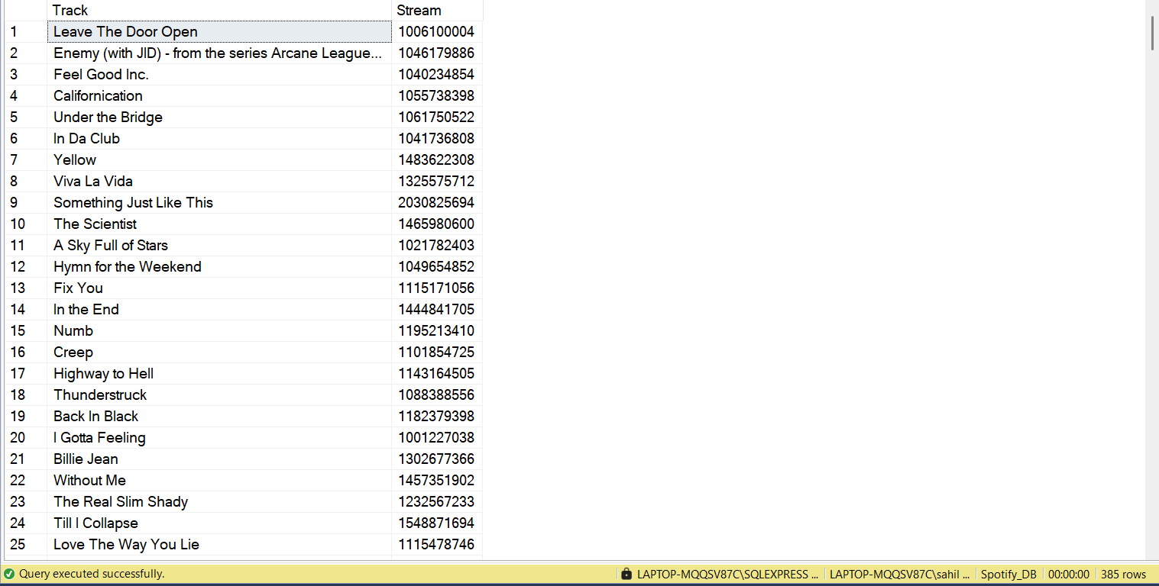

(Q2) List all the albums with their respective artists

SELECT

COUNT(DISTINCT Album) Total_Albums

FROM Spotify_Data

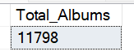

Here one thing to Conlude that More than One Artist made the Album

SELECT

DISTINCT Album,

Artist

FROM Spotify_Data

ORDER BY Album

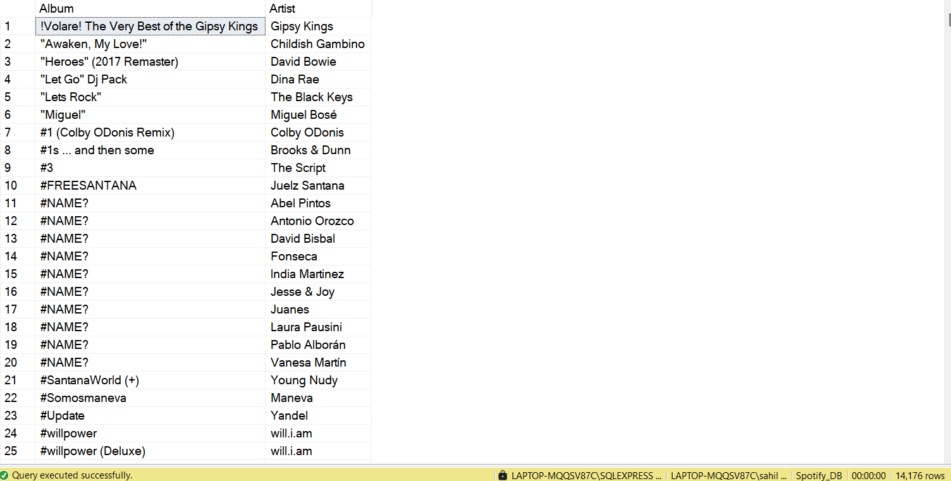

(Q3) Get the total number of comments for tracks where licensed = True

SELECT

FORMAT((SUM(Comments)) ,'N0', 'en-US') Total_Comments

FROM Spotify_Data

WHERE Licensed = 'TRUE'

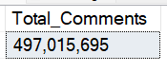

(Q4) Find all the Track that belong to album type single.

SELECT * FROM Spotify_Data

WHERE Album_type = 'Single'

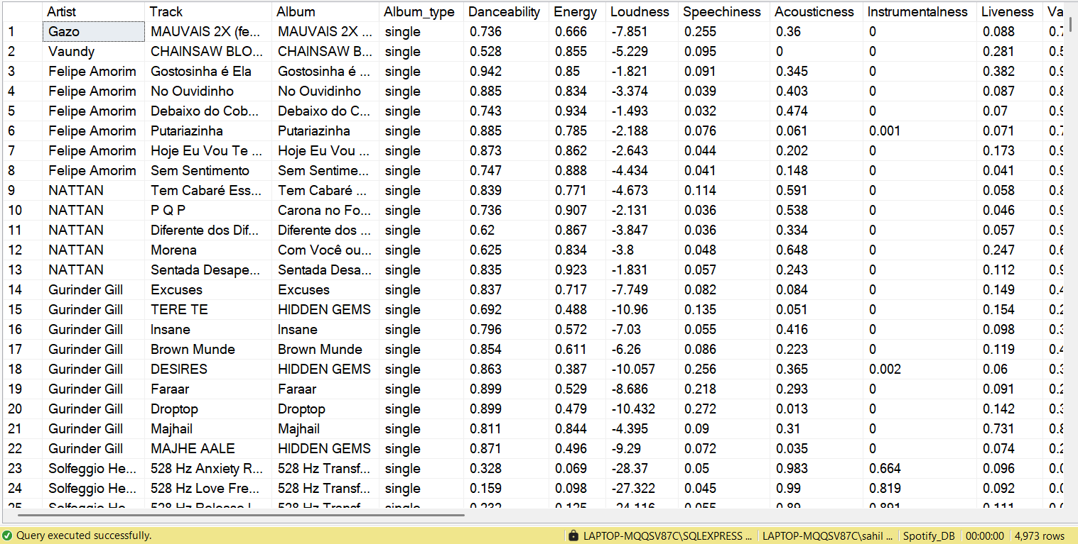

(Q5) Count the Total Number of tracks by each artist

SELECT

Artist,

COUNT(Track) Total_Nr_Track

FROM Spotify_Data

GROUP BY Artist

ORDER BY

COUNT(Track) DESC

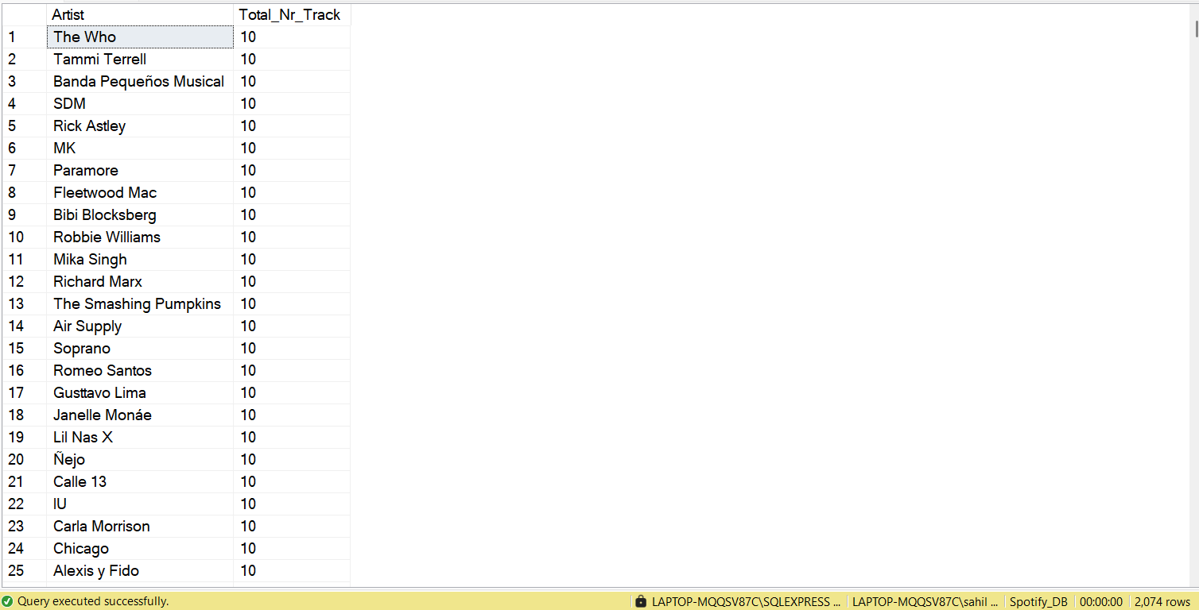

===================================================

**Data Analysis Intermediate Level**

===================================================

(Q6) Calculate the Average Danceability of tracks in each album

SELECT

Album,

AVG(Danceability) Avg_Danceability

FROM Spotify_Data

GROUP BY Album

ORDER BY

AVG(Danceability) DESC

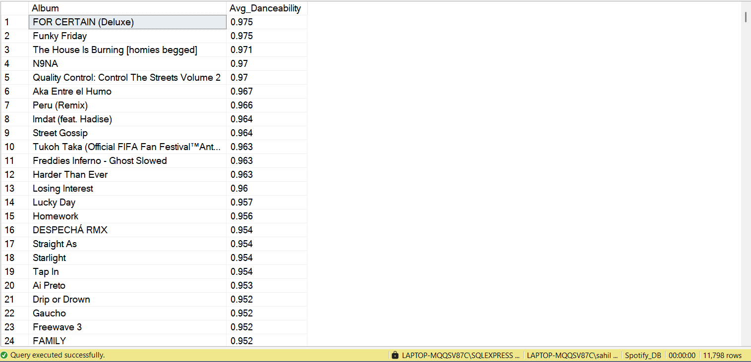

Extra thing I noted here that There are album which have more than one track

SELECT

Album,

COUNT(TRACK) Number_of_Tracks

FROM Spotify_Data

GROUP BY Album

ORDER BY

COUNT(TRACK) DESC

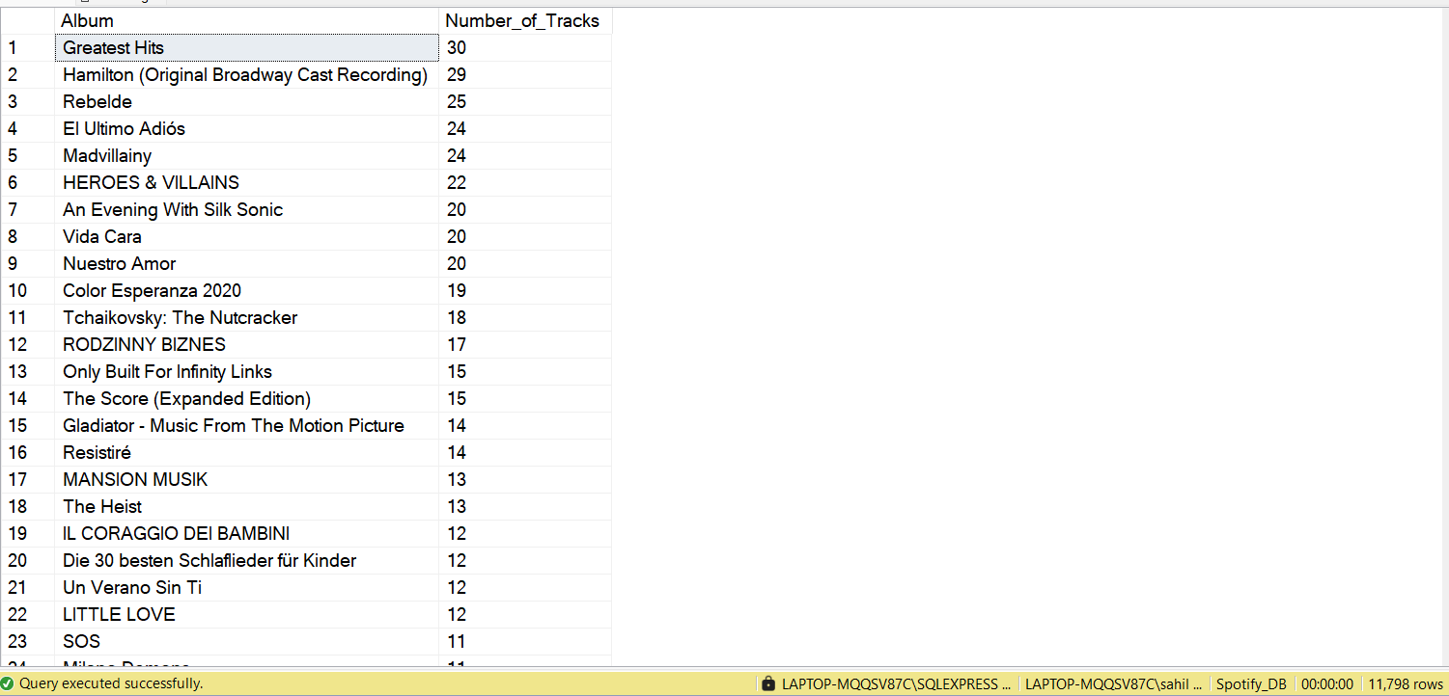

(Q7) Find the Top 5 Tracks with highest energy values

SELECT TOP 5

Track,

MAX(Energy) Max_Energy

FROM Spotify_Data

GROUP BY Track

ORDER BY

MAX(Energy) DESC

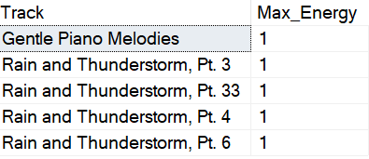

(Q8) List all tracks along with views and likes where official_video = True

SELECT Track,

SUM(Views) Total_Views,

SUM(Likes) Total_Likes

FROM Spotify_Data

WHERE official_video = 'TRUE'

GROUP BY Track

ORDER BY

SUM(Views) DESC

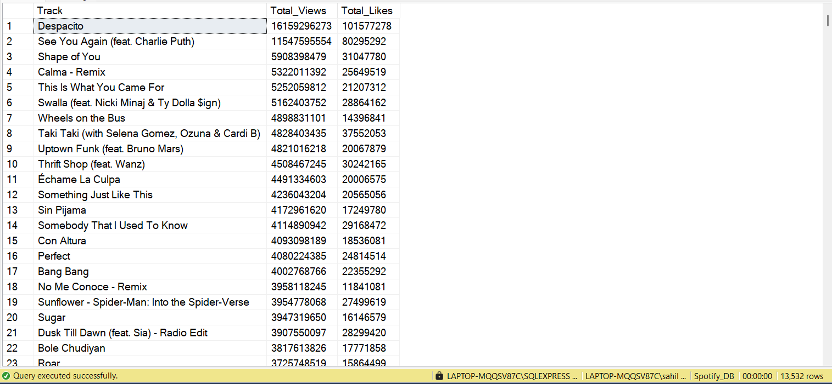

(Q9) For each album, Calculate the total views of all tracks

SELECT

ALBUM,

Track,

SUM(Views) Total_Views

FROM Spotify_Data

GROUP BY Track,Album

ORDER BY

SUM(Views) DESC

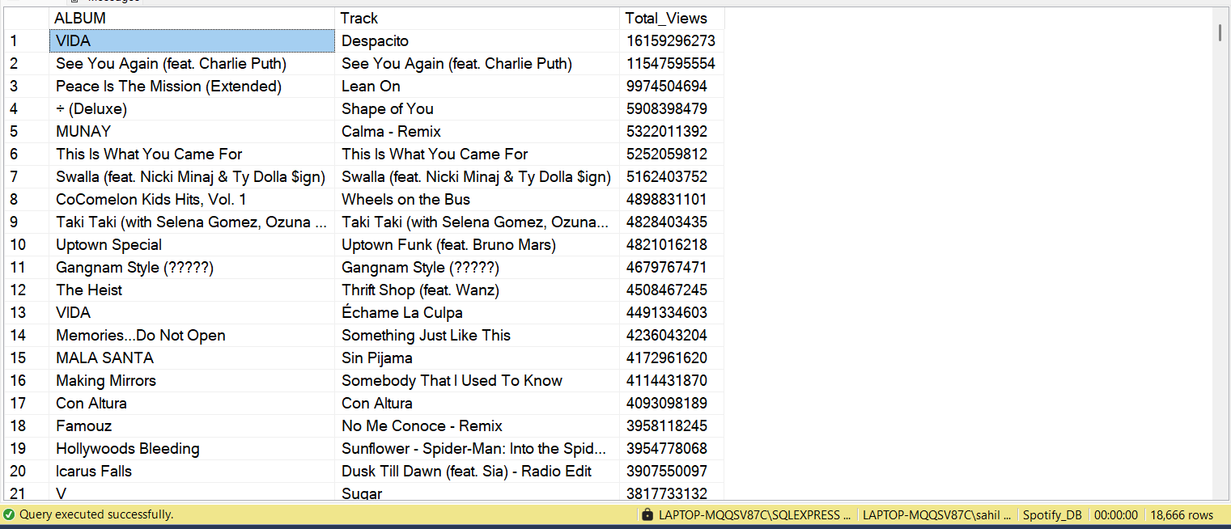

(Q10) Retrieve the Track names that have been streamed on Spotify more than Youtube

SELECT

Track,

SUM(CASE WHEN most_playedon = 'Youtube' THEN Stream END) Stream_on_youtube,

SUM(CASE WHEN most_playedon = 'Spotify' THEN Stream END) Stream_on_Spotify

FROM Spotify_Data

GROUP BY Track

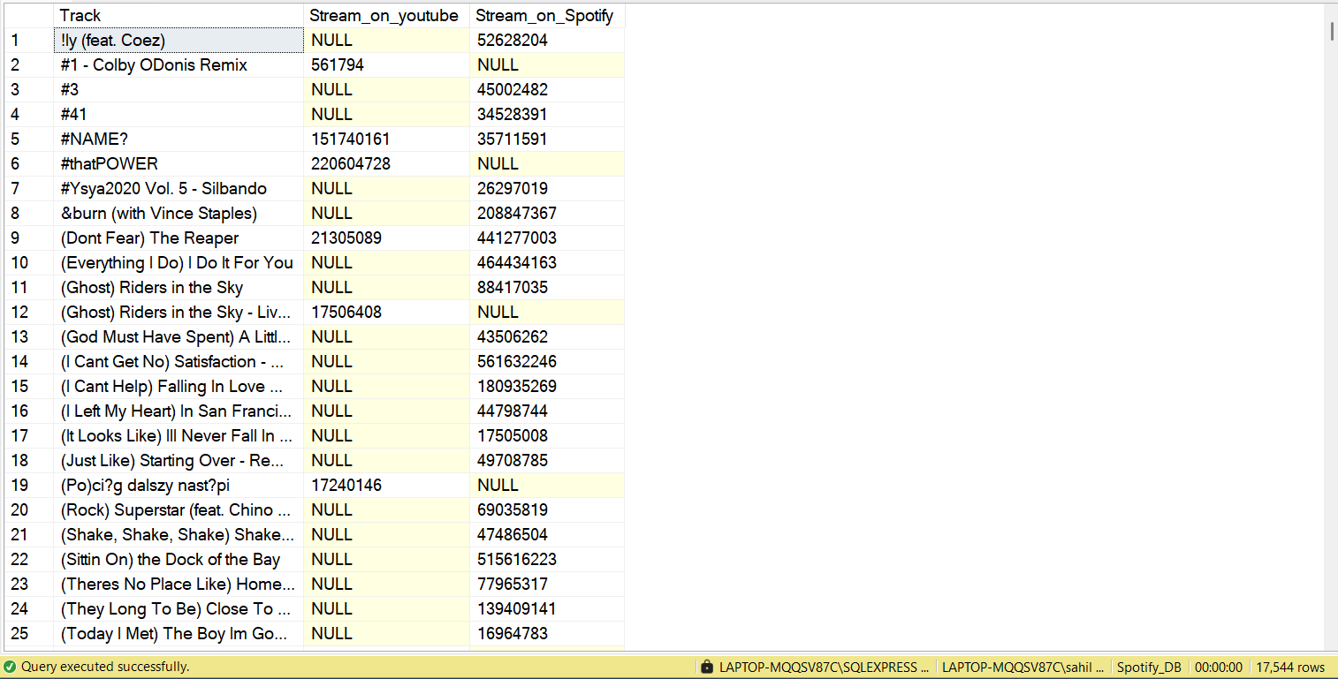

We can Notice that Most of the songs are not streamed on both the platform

SELECT * FROM

(SELECT

Track,

COALESCE(SUM(CASE WHEN most_playedon = 'Youtube' THEN Stream END),0) Stream_on_youtube,

COALESCE(SUM(CASE WHEN most_playedon = 'Spotify' THEN Stream END),0) Stream_on_Spotify

FROM Spotify_Data

GROUP BY Track) AS T1

WHERE

Stream_on_Spotify > Stream_on_youtube

AND

Stream_on_youtube <> 0

ORDER BY Stream_on_Spotify DESC

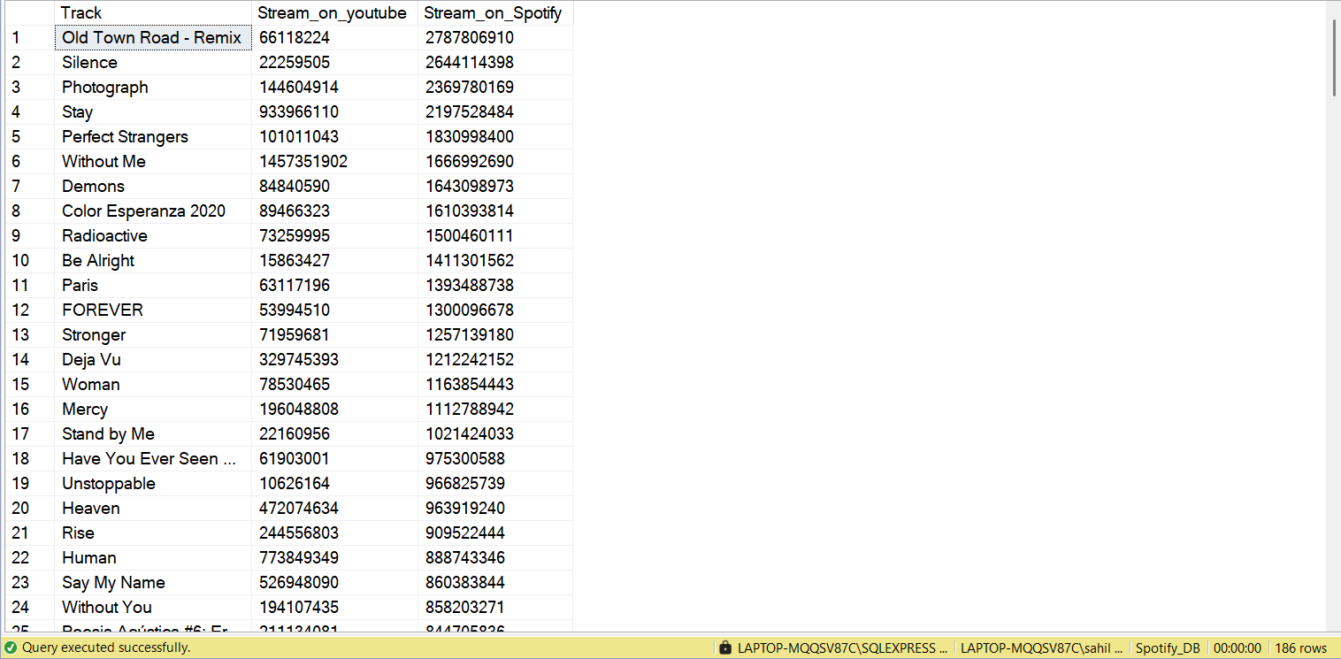

===================================================

**Data Analysis Advance Level**

===================================================

(Q11) Find Top 3 most viewed tracks for each artist using window functions

-> First we will find Each Artist and Total view for each Track

-> Second Track with Highest View for each Artist( We need Top3)

-> Third use Dense Rank function and CTE

WITH Ranking_Artist

AS(

SELECT

Artist,

Track,

SUM(Views) Total_Views,

DENSE_RANK() OVER(PARTITION BY Artist ORDER BY SUM(Views) DESC) Rank

FROM Spotify_Data

GROUP BY Artist,Track

)

SELECT * FROM Ranking_Artist

WHERE Rank<=3

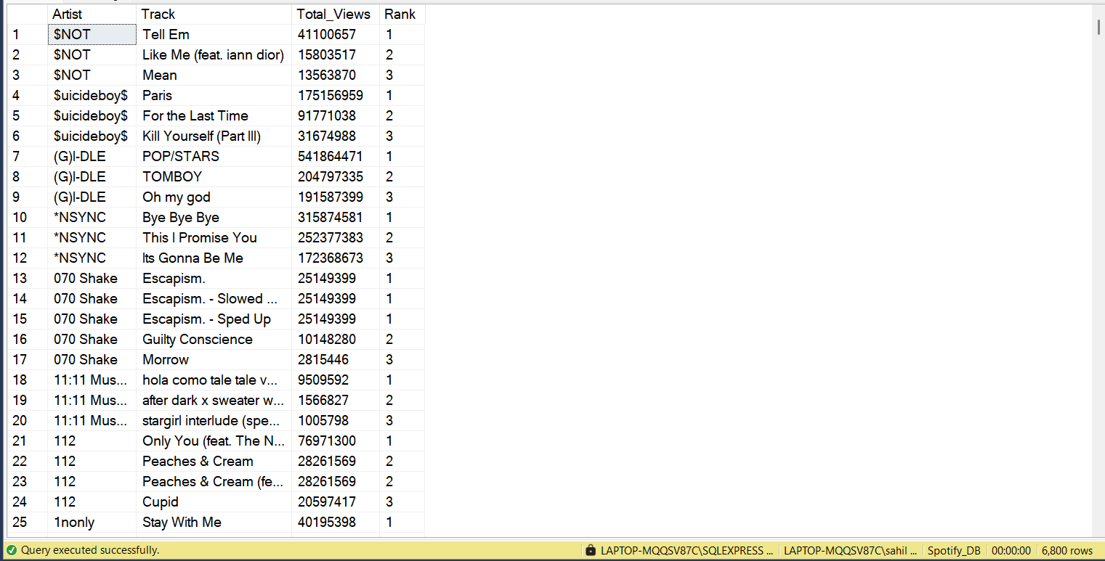

(Q12) Write a Query to find Tracks where the liveness is above Average

SELECT

Track,

Artist,

Liveness

FROM Spotify_Data

WHERE Liveness> (SELECT AVG(Liveness) FROM Spotify_Data)

ORDER BY Liveness DESC

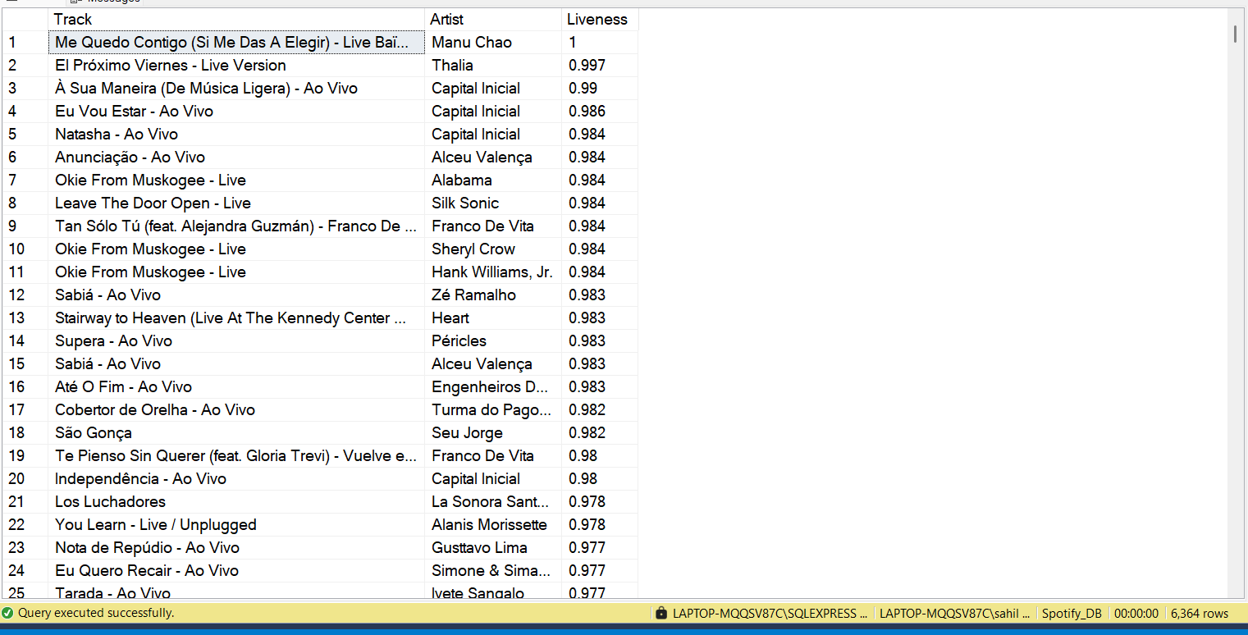

(Q13) Use a with Clause to calculate the difference between the Highest and lowest energy values for tracks in each album

WITH Energy_of_Album AS

(

SELECT

Album,

MAX(Energy) Highest_Energy,

MIN(Energy) Lowest_Energy

FROM Spotify_Data

GROUP BY Album

)

SELECT Album, Highest_Energy - Lowest_Energy as Energy_difference

FROM Energy_of_Album

ORDER BY 2 DESC

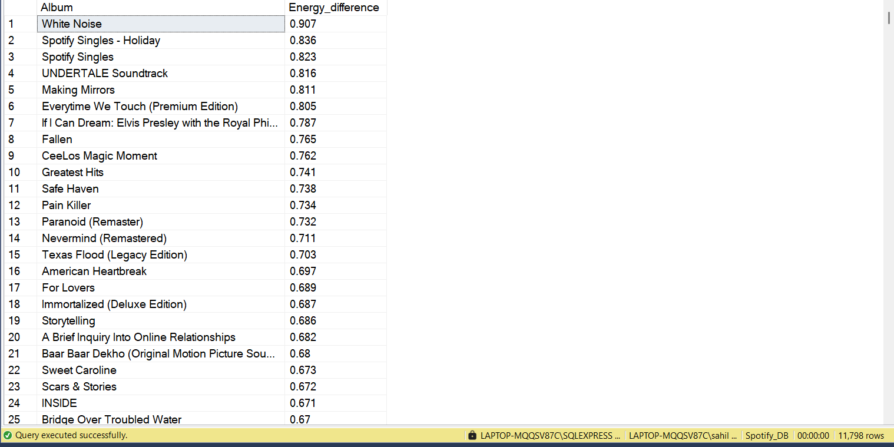

(Q14) Find tracks where the energy-to-liveness ratio is greater than 1.2.

SELECT

Track,

EnergyLiveness FROM Spotify_Data

WHERE EnergyLiveness> 1.2

ORDER BY

EnergyLiveness DESC

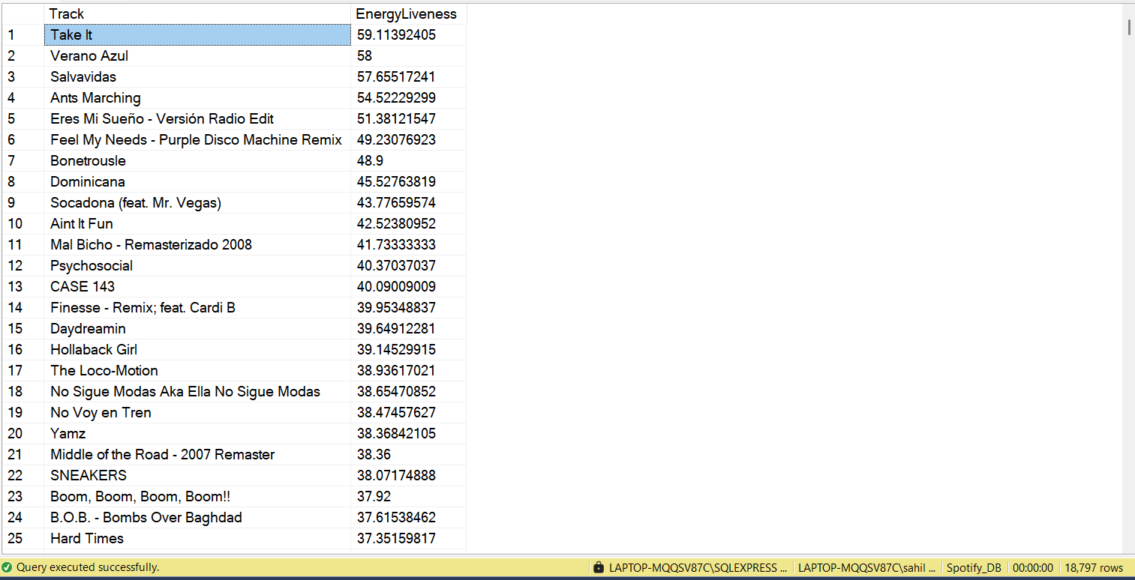

(Q15) Calculate the cumulative sum of likes for tracks ordered by the number of views, using window functions.

SELECT

Track,

SUM(TotalLikes) OVER (ORDER BY TotalViews DESC) AS CumulativeLikes

FROM (

SELECT

Track,

SUM(Views) AS TotalViews,

SUM(likes) AS TotalLikes

FROM Spotify_Data

GROUP BY Track

) t3

ORDER BY TotalViews DESC;

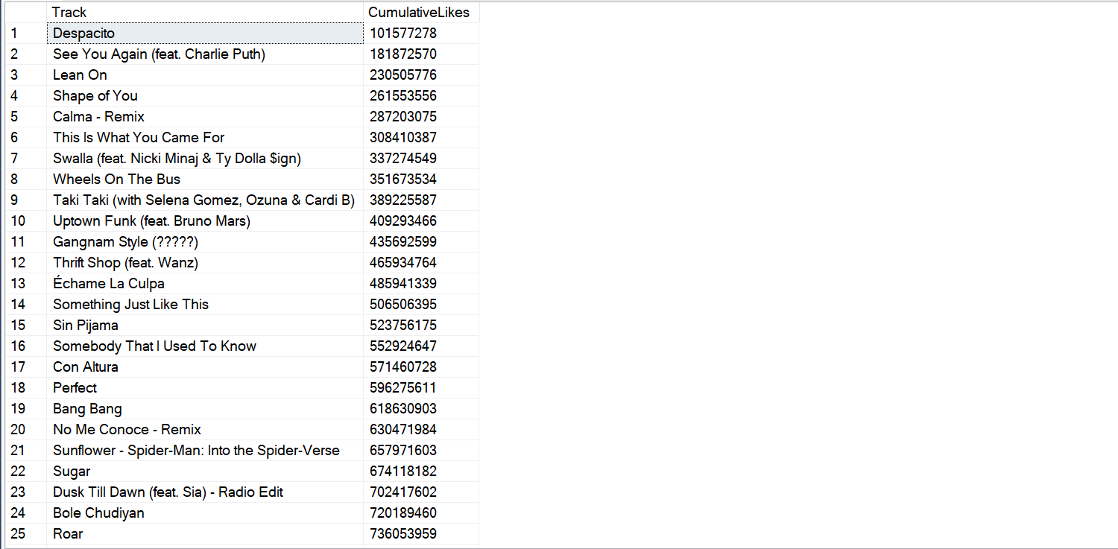

**Query Optimizations**

SELECT

TOP 25

Artist,

Track,

Views

FROM Spotify_Data

WHERE

Artist ='Gorillaz'

AND

Most_playedon = 'Spotify'

ORDER BY

stream DESC

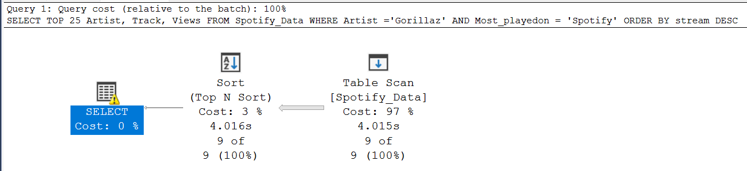

CREATE INDEX Artist_Index ON Spotify_Data (Artist)

-- Ran query after creating Index

SELECT

TOP 25

Artist,

Track,

Views

FROM Spotify_Data

WHERE

Artist ='Gorillaz'

AND

Most_playedon = 'Spotify'

ORDER BY

stream DESC

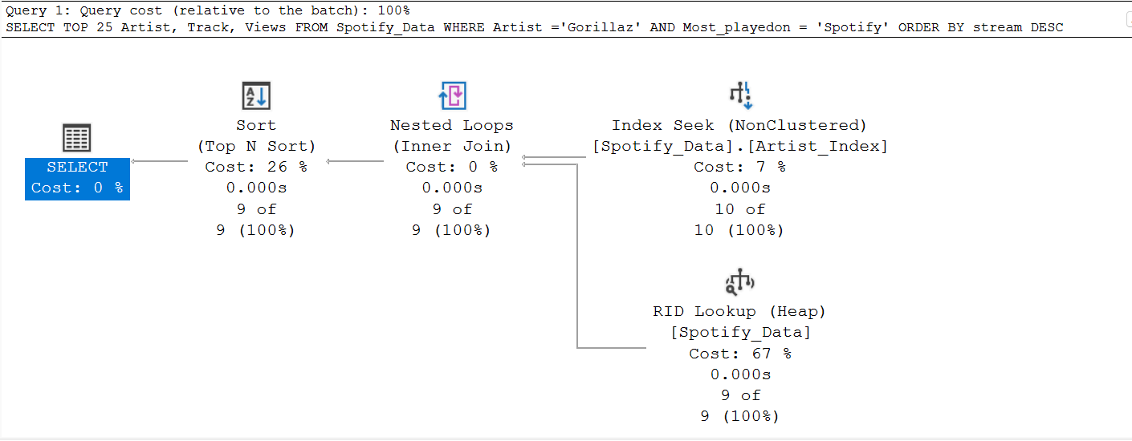

By this way we can optimize performance of Queries